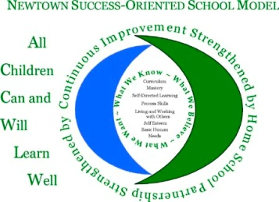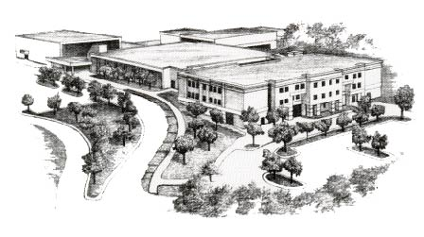Newtown High School
12 Berkshire Road
Sandy Hook, CT 06482
(203) 426-7646
FAX (203) 426-6573

August, 2013

Dear Students, Parents, and Guardians,

Welcome to Junior Year for the Class of 2015! We would like to re-introduce ourselves as your advisors for the Class of 2015. Mr. J.Edwards returns, to continue working with you and your class as the second half of high school begins! Mr. Gary Franklin joins the Class of 2015 as an Advisor, following his successful first year of teaching at NHS, and after his three years as a Student Council and Class Advisor at Thomaston High School. We are excited to work with you this year, as we help you prepare for the future and to contribute to an enjoyable and meaningful NHS experience.

Our goals as class advisors are to communicate with you as efficiently and effectively as possible; to involve you in a variety of events, activities and service opportunities for your class; to develop meaningful life skills, all while enjoying your Junior Year experience. Communication is of utmost importance to us, and we intend to make use of technology, including the Google Messenger outreach network for phone and email notifications. We also plan on utilizing online resources to provide you the opportunity to keep yourself informed, such as Mr. Edwards’ Twitter account (follow “@mrEnhs”). We have clear expectations for you as students for event deadlines, behavior as role models for the school community, and as representatives of Newtown High School. We need your participation, self-direction and follow-through to make this year the best it can be.

Please check http://dumais.us/newtown/blog/ from time to time to be aware of what is happening in your school community, or either one of our own teacher websites. In addition, please check the NHS homepage link titled http://newtown.nhs.schooldesk.net/ [It’s labeled as “NHS Class Folders” under “Information”] for forms and information throughout the year. Keep yourselves informed!

We need interested students to apply for membership on the Class of 2015 Executive Council. Any interested student must fill out an application, and interviews for selected students will be conducted within the first few weeks of school. Pay attention in homeroom for information about the application, due dates, interviews, and anything else going in and around NHS.

As we begin working together, let us close with our hope for a happy and healthy Junior Year for the Class of 2015!

Sincerely,

Mr. G. Franklin Mr. J. Edwards

